# Assignment 2

1. Save workbook as A00878763 Assignment 2
2. Data > Get Data > From workbook > From File - Assignment 2 Data
   1. Select the Status table
   2. Load data as Connection Only
   3. Do NOT add the data to the data model
3. Make sure the query is called Status
4. Data > Get Data > From Workbook > From File – Assignment 2 Data
   1. Select Sales table
   2. Transform Data
5. In the Sales Query
   1. Change the **AdoptionDate** data type to Date only
      1. Add Column > Date > Month > Name of Month
      2. Name that new column AdoptionMonth
   2. **Calculate the Profit** (Price-Cost).
      1. Format the Cost and Price Fields as Currency
      2. Do Price - Cost
      3. Make sure to set field type of profit to currency
      4. Name the column profit
   3. **Calculate Donation**
      1. Custom Column
      2. In the Custom column formula: Profit * 0.5
      3. Name the column Donation
   4. **Calculate Vet Fee**
      1. Add a conditional column where:

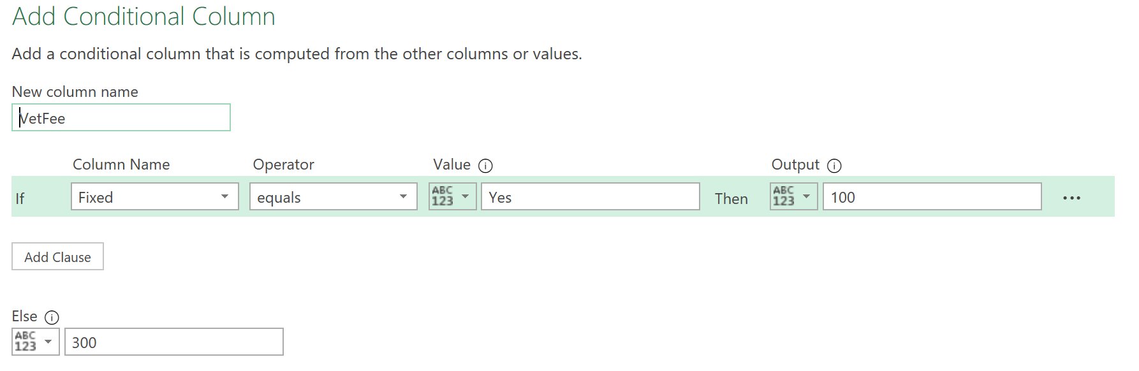

* + 1. Make sure that the VetFee is set to Currency
  1. **Calculate TotalPrice**
     1. Price + VetFee
     2. Make sure it is set to currency
  2. **Filter December Options out**
     1. Click the dropdown array beside Month Name and uncheckmark December
  3. **Add PriceRange Column**
     1. Add a Conditional Column

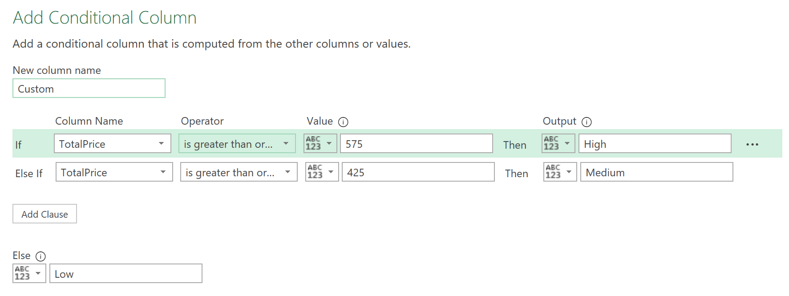

* 1. Home > Close & Load > Load Too..
     1. Connection Only
     2. Add data to the data model
     3. Make sure the query is names sales

1. Merging Queries
   1. Open up the Sales Query
   2. Home > Merge Queries
   3. From the drop down select Status
   4. Then highlight the StatusID from both tables
   5. Filter out the StatusID from the Status Column
   6. We can remove the StatusID column
   7. Rename the new column AdoptionStatus

# Assignment Questions

1. How many rows are in the Sales query? [1] **96**
2. How many columns are in the Sales query? [1] **16**
3. On Sheet1 of your workbook, create a pivot table that shows the total donations by Month. Your pivot table should have the following characteristics [3]

* Show Donation as value, AdoptionMonth as row
* Format your Donation number value as Accounting
* Format your Donation number to zero decimal places
* Rename your value field to DonationAmt
* Remove field headers
* Rename your pivot table to Donations

---

My Notes:

1. Insert > PivotTable > From Data Model
   1. Existing worksheet
   2. Add values to field areas

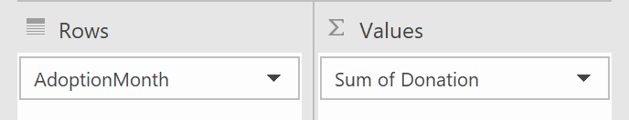

1. Click on Sum of Donation and then > Value Field Settings > Number Format
   1. Set to Accounting with zero decimal places
2. Rename field to DonationAmt
3. Remove Field Headers ( PivotTable Analyze > Show > Field Headers (unselect))
4. Rename PivotTable to Donations (PivotTableAnalyze > PivotTable > Under PivotTableName: Donations)

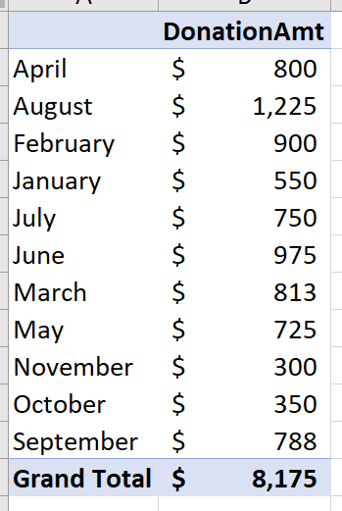

---

1. Referencing this pivot table, how many months have donations less than $400? [1] **2**
2. Continuing in Sheet1 of your workbook, create a pivot table that shows the total number of Finalized adoptions of Cats and Dogs by Region. Your pivot table should have the following characteristics [2]

* Use OrderID as value, Region as row, PetType as column
* Filter on AdoptionStatus
* Apply Green Data Bar conditional formatting for all cells showing values for Region and PetType
* Remove Grand Totals

---

My Notes:

1. Insert > PivotTable > From Data Model
2. Add fields as:

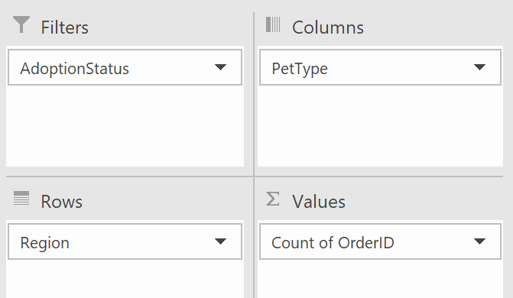

1. MAKE SURE that OrderID is set to COUNT!!
2. Click on a cell inside that PivotTable preview pane
   1. Home > Conditional Formatting > Data bars > Green Data Bar
   2. Then hover over that one green database and make sure it is set to show values for Region and PetType

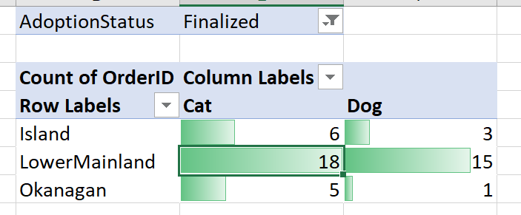

---

1. Referencing this pivot table, how many cat adoptions were finalized in the Okanagan? [1] **5**
2. Continuing in Sheet1 of your workbook, create a pivot table that shows the percent breakdown of pet adoptions by price range. Your pivot table should have the following characteristics [3]

* Use OrderID as value, PriceRange as row
* Show value as a percent of Grand Total
* Apply column banding
* Rename your value field to “AdoptionBreakdown”
* Remove field headers
* Sort values from largest to smallest

---

My Notes

1. Add in the values to the fields:

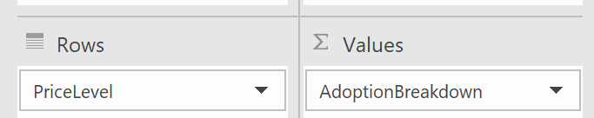

1. Right click in one of the number cells and then go to Show Value as > % of Grand Total
2. Right click in one of the % values and go to Sort > Largest to Smallest
3. Design > PivotTable Style Options > Banded Columns

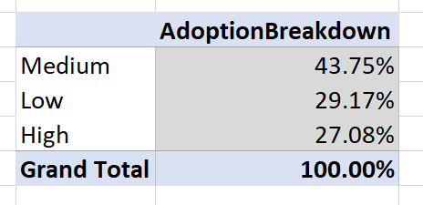

---

1. Using this pivot table, what percentage of adoptions were in the Low price range? [1] **29.17%**
2. Continuing in Sheet1 of your workbook, insert a 2D Pie Chart based on the pivot table you created in step 7 [2]

* Rename the chart “Price Breakdown”
* Add outside-end data labels
* Hide all field buttons on the chart
* Use the Move Chart function to move your chart to a new worksheet called Chart1

---

My Notes:

1. Select the entire table AdoptionBreakdown
2. Insert > Charts > pie chart > 2D Pie
3. Rename the title to Price Breakdown
4. Remove outside-end data labels by
5. Right click the Pie Chart > Format Data Labels
6. Right click the data labels then click Format Data Labels and set it to Outside-end data labels
7. Hide all field buttons
   1. PivotChart Analyze > Show/Hide > Field Button > All
8. Right click Chart > Move Chart > new Sheet

---

